**Lingen Davies Cancer Fund**

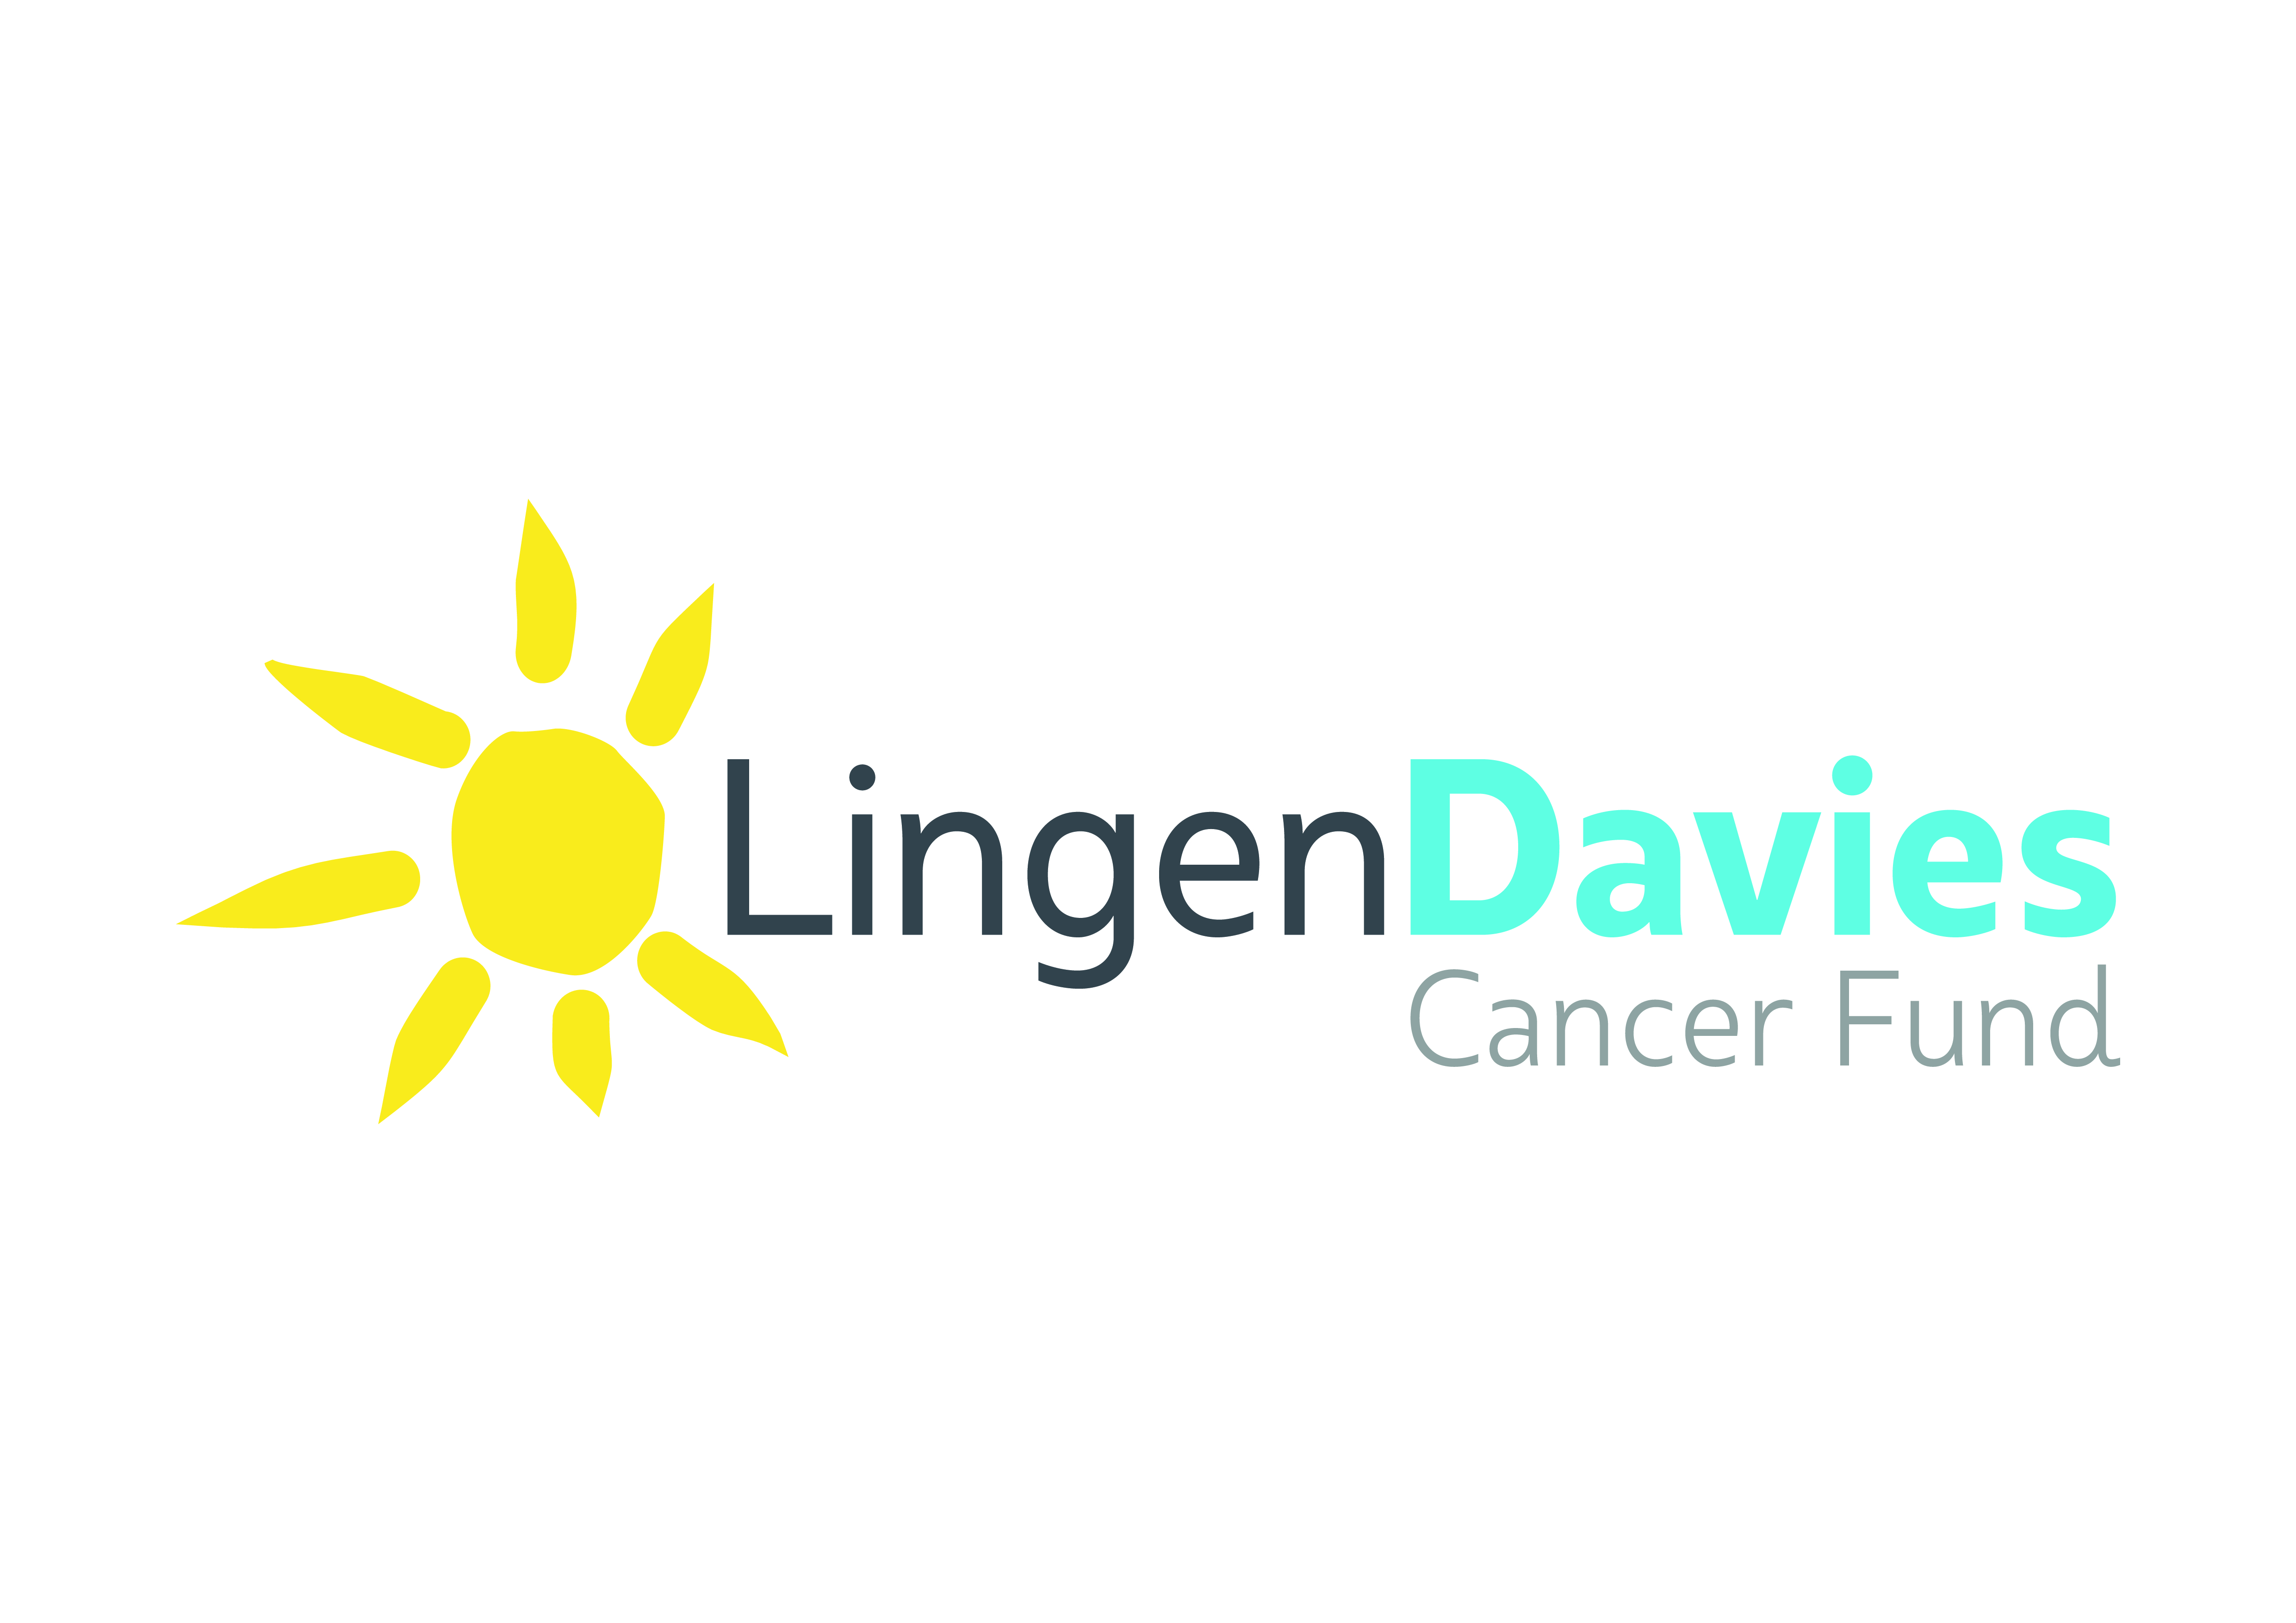

**Grant and Funding Application Form**

Applications to the Lingen Davies Cancer Fund for a grant or funding allocation must be submitted on this form.

The applicant is advised to read the guidance notes that accompany this form to ensure compliance with the charity’s requirements.

This form may be accompanied by a business case or detailed proposal document.

You should consider Section 8 before completing the form as this refers to how the grants outcomes will be measured. See guidance notes.

The Lingen Davies Cancer Fund exists to make a positive difference to lives affected by cancer in Shropshire, Telford & Wrekin, and Mid Wales; Trustees are keen to use the fund to maximise the Charity’s ability to achieve its objectives.

**SECTION 1 – The Applicant (organisation)**

*Guidance Notes*

1.7

5.4

5.10

5.11

**Name of Lead Applicant:**

**Address of Lead Applicant:**

**Name of Contact: Contact Phone Number:**

**Email address:**

**Name of Partner Organisation (s)**

**(if applicable):**

**Address:**

Note – all applications must be accompanied by a signed statement of support from the accountable officer of the applicant organisation(s) (See Section 8). You are encouraged to ensure you are able to obtain this before proceeding with this application.

**SECTION 2 – The Summary**

*Guidance* Notes

1.12

1.8

**Summary of Proposal:** [NOTE- This section **MUST** be completed]

*Guidance* Notes

1.8

2.4

**Quantify the scale of impact (e.g. number or type of patients):**

**SECTION 3 - The Detailed Proposal**

*NOTE: If a business case is submitted in support of the application, it is acceptable to refer to the case by name here; section 3 is then optional. i.e. see enclosed case ”……….” ]*

*You should however ensure the case fully meets the requirements of each of the sections below. If not, each specific section must be completed*

**Describe the detail of the proposal:**

*Guidance* Notes

1.8

2.2

2.4

2.5

**Describe the expected benefit and outcomes:**

*Guidance Notes*

1.5

1.6

1.13

2.4

3.1

3.3

*Guidance Notes*

3.1

3.2

**Describe how this proposed benefit and outcomes will be measured:**

*Guidance Notes*

3.1

3.2

**Describe the risks you have identified and the steps you will take to mitigate them:**

*Please rate each of these on the standard Impact and Likelihood scoring (1-5).*

*Guidance Notes*

1.1

1.4

3.1

3.2

**Describe the user/carer involvement in developing this proposal:**

**Set out timescales for implementation e.g. Gantt Chart:**

*Guidance Notes*

3.4

**SECTION 4 Finance**

*Guidance Notes*

1.10

1.12

2.5

4.1

**Detail the funding required. This should include timing of funding allocation:**

*Guidance Notes*

1.14

1.15

2.5

4.3

4.4

4.5

**Is this grant the only source of funding for this project?**

**If not, please name the other co-funders, their contribution to the total and whether that funding has been approved.**

*Guidance Notes*

1.10

**Are there revenue costs associated with this programme?**

**Please detail how these will be met.**

**SECTION 5 - Governance**

*Guidance Notes*

1.8

2.3

3.1

3.2

**Is this application supported by the Lead Applicant’s accountable officer:**

**Please provide evidence to demonstrate this:**

**Does this comply with the local / national commissioning strategy for cancer services?**

**Please provide evidence to demonstrate this:**

*Guidance Notes*

1.9

*Guidance Notes*

3.1

3.2

**How will this project be reported and managed within the Lead Applicant.**

**SECTION 6 - Scope**

*Guidance Notes*

1.2

1.4

3.6

**Is this application entirely for cancer patients’ benefit?**

**If no; please detail how the non-cancer element will be funded**

**Is this application entirely for patients living within Shropshire, Telford & Wrekin and/or Powys?**

**If no; please detail how the non-resident element will be funded:**

*Guidance Notes*

1.1

1.2

3.6

The following pages cover the declarations required of the Lead Applicant.

Applicants are encouraged here to check their submission details before proceeding to the final page.

**SECTION 7 – Measuring the Outcomes and Benefits.**

**Aligning to Lingen Davies Strategic Objectives**

Please state the main Lingen Davies strategic objective to which this bid is aligned.

* **Improving Cancer prevention in our community.**
* **Enhancing cancer treatment and services locally.**
* **Support people to live well, with and beyond Cancer**

Show how you can demonstrate meeting this objective from statements you have already made in your bid.

**Statement 1:**

**Measurement 1:**

**Statement 2:**

**Measurement 2:**

(please repeat as often as required)

**Secondary Strategic Objectives (**Where applicable)**.**

*Guidance Notes*

6.2

3.1

3.2

3.3

6.3

6.6

6.4

6.8

6.9

6.5

6.7

**SECTION 8 – Agreement and Sign Off**

**Grant Agreement:**

**I have read the proforma Grant Agreement and confirm that the Lead Applicant will enter into this agreement on confirmation of funding.**

Yes /No

*Note – if you are unable to confirm this statement you should not proceed with this application.*

*Guidance Notes*

1.8

2.3

3.7

5.9

**If accompanying papers are included with this application, please give the titles of these documents so that Trustees can ensure they have access to all supporting material**



*Guidance Notes*

2.2

2.5

**I confirm that this application is complete and that it represents the full facts and costs of the proposal**

**I confirm that I have taken all reasonable steps to test any assumptions in this application.**

Signed:

Position:

Date:

Letter of Support enclosed Yes/No

Organisational Board minutes confirming support enclosed Yes/No

Applicants are encouraged to submit electronically to [louise.dawson@lingendavies.co.uk](mailto:louise.dawson@lingendavies.co.uk)